**Threat zone of an explosion particularly in oil and**

**gas industries or refineries**

Mr. Prasantha Kumar sahoo 1, M. Sai Venkata Ramana2, S. Vasisht Iyenger 3, B. Eshanth 4

*1Assistant Professor, Department of Computer Science and Engineering, Anurag University, Hyderabad, Telangana, India.

*2, 3, 4 UG Student, Department of Computer Science and Engineering, Anurag University, Hyderabad,

Telangana, India.

*Corresponding author’s email*:[21eg105h38@anurag.edu.in](mailto:21eg105h38@anurag.edu.in)

**ABSTRACT**

The project aims to address the critical need for a robust explosion risk assessment tool in the oil and gas industry, particularly in oil and gas refinery environments where safety is paramount. Traditional methods of threat assessment are often manual, subjective, and limited in their capacity to provide real-time insights, which poses significant challenges for industry professionals in managing potential hazards. Our project leverages real-time weather data and machine learning algorithms to develop an advanced web application designed to identify and assess threat zones within oil and gas refineries. By utilizing refinery-specific datasets, real-time weather parameters, and machine learning models, the application enables users to upload or access refinery data, select industry-specific details, and receive accurate risk predictions along with stability class assessments.

The application integrates the OpenWeatherMap API to provide up-to-date weather information, while a Random Forest classifier used for gas classification and some other parameters are calculated and trained on relevant features such as wind speed, cloud cover, and insolation levels to predict explosion risks. Designed with an intuitive, user-friendly interface, this tool will be invaluable for safety engineers, refinery managers, and environmental professionals, facilitating proactive risk management and informed decision-making. By addressing limitations in current risk assessment methods—such as limited access to real-time environmental data, variable risk levels, and lack of predictive analytics—our project aims to provide a comprehensive, data-driven solution for managing safety and mitigating risks in high-stakes industrial environments.

**Keywords:** Gas Classification, OpenWeatherMap API,Insolation Calculation, Predictive Analytics, Explosion Efficiency, Risk Prediction.

**1. Introduction:**

The *threat zone of an explosion in oil and gas industries or refineries* refers to the geographic and environmental impact radius in which an explosion's shockwaves, heat, and potentially hazardous emissions can cause significant harm to people, infrastructure, and the surrounding environment. Due to the highly flammable materials such as hydrocarbons and hazardous chemicals present in these facilities, any explosion can have catastrophic consequences, often amplified by factors like weather conditions, proximity to residential areas, and storage volumes of flammable substances. By identifying the radius and characteristics of potential explosion impacts, industries can enhance safety protocols, create effective emergency response strategies, and ensure protective measures for both personnel and the public. Parameters like wind speed, insolation, and stability classes play vital roles in determining how far and intensely the effects of an explosion might spread, making it essential to integrate meteorological and environmental data into threat zone models.

**2. Research Methodology:**

This project aims to identify the risk of explosion in the oil and gas industries or refineries by using the classification of gases and open weather api to find the insolation of industrial areas of the location. Insolation is the amount of solar radiation that reaches a surface area over a specific period of time. The model uses existing knowledge and data processing to accurately recognize different gases, making it easier to find information about them. The research shows how explosive gas classification can be useful to find the risk and predict the analysis while also pointing out challenges like data variety and model performance.

1. **Data Collection and Preprocessing**: Gas and oil from the different industries were collected from publicly available datasets and split into training and validation sets. Data preprocessing steps included handling missing values, normalizing variables, and extracting important features like wind speed, cloud cover, and solar insolation levels. The images underwent pre-processing to standardize them for model training. Using the StandardScaler and RandomClassifier for gas classification, various augmentation techniques were applied to enhance the dataset’s diversity. This ensured that the model generalizes better to different image variations.
2. **Model Architecture**: This model architecture could be modified based on additional data or requirements, such as more features or a greater diversity of gas types. The setup allows you to predict the likelihood of explosion risk given the input features. The classification model is built and pre-trained on the dataset. Gas type learning was employed, risk category, accuracy of explosion and adding custom classification layers on top.
3. **Model Training and Evaluation**: The model was trained on the augmented dataset for industries of gases and oil, with training and validation sets.The performance of the model was evaluated using accuracy, precision, recall, and F1-score, with particular focus on the model's ability to correctly classify the gases and chemicals exposing to high explosive threat zones. After satisfactory performance was achieved, the model was saved as a python file for future use.
4. **Web Application Development**: To deploy the model, a web application was developed using Streamlit, a Python-based framework for creating interactive web apps. The application allows users to upload gases and chemicals of specific industries and receive classification results in real time. The saved longitudes and latitudes of the industries are helpful to locate its weather conditions through weather api which helpful to calculate its climate conditions like insolation, cloud clover, wind speed and gas classification model is loaded via TensorFlow, and normalizing chemical values before feeding it into the model for prediction. After classification, users can ask questions related to the classified industries, able to analyze the risk prediction of explosion in the threat zone. This interaction is made possible by integrating the OpenWeatherMap API, enabling real-time.

**Flow diagram**

1. 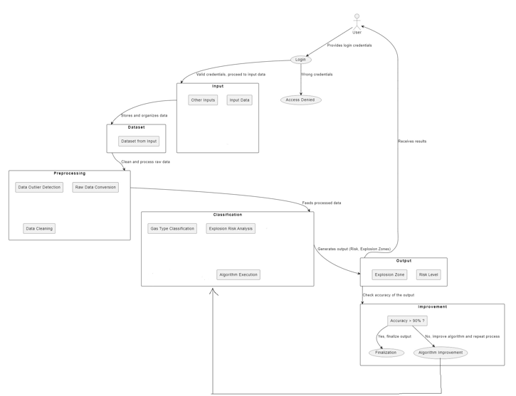

**3. Theory and Calculation:**

The identification of explosion risks of oil and gas refineries in a threat zone through gas classification uses machine learning techniques, especially classifiers. Machine learning has changed data processing by automating tasks that previously human expertise. OpenWeather API is used to find the climate conditions of particular industrial areas which are taken by the longitude and latitude from the data set, allowing the model to learn complex patterns. Also we use gas classification methods that build a model for the industrial gas and oils that are present, allowing it to perform well in identifying gas and oils, even with a smallest dataset.

In this project, we use interactive maps, known for being efficient and effective in classification to find threat zone areas based on climate, including current weather data, forecasts, and historical weather data. From the gathered data we can calculate the parameters like insolation(the amount of solar radiation that reaches to surface the area), measured in Kilowatts per square meters. To obtain insolation we also find that related parameters like Wind Speed, Cloud Cover, Solar Zenith Angle, Daytime Insolation (Q)

Stability Class. These are helpful to find explosive risk to specified refineries.

During training, the model learns to minimize prediction errors by adjusting its internal parameters based on the loss function, which measures the difference between predicted and actual classifications. After training, the model's performance is evaluated using accuracy, precision, recall, and the F1-score, which together show how well the model identifies plants. These calculations help understand the model's effectiveness and contribute to advancements in automated medicinal plant identification in healthcare.

**3.1. Mathematical Expression and Symbols**

Several mathematical expressions and symbols are used to describe the processes involved in model training and evaluation.

**Model Training:** The training process involves calculating the categorical insolation energy of the threat zone defined as:

Q is the daytime insolation (in watts per square meter),

S is the solar constant (1361 watts per square meter),

r is the Earth's distance from the Sun (in meters),

is the Earth's mean distance from the Sun (149.6 million meters),

is the solar zenith angle (the angle between the sun's rays and the vertical)

r =

d is the number of days since january 1st

hourangle =

N is the day of the year(1-365)

where Q represents the Insolation (Kilowatts per square meter), S represents the Solar Constant, and N is the number of days. Based on the angle of the area and earth distance to that area we find zenith angle and distance.

**Prediction and Evaluation Metrics:** After training, the model's performance is evaluated using accuracy, precision, recall, and F1-score. Accuracy is calculated as:

Accuracy =

Precision and recall are calculated based on true positives (TP), false positives (FP), and false negatives (FN):

Precision = and Recall =

The F1-score, which balances precision and recall, is given by:

F1 Score = 2 *

**4. Results and Discussion**

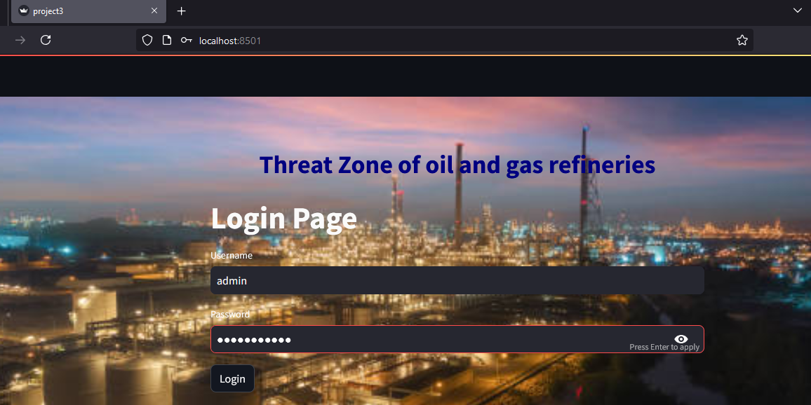

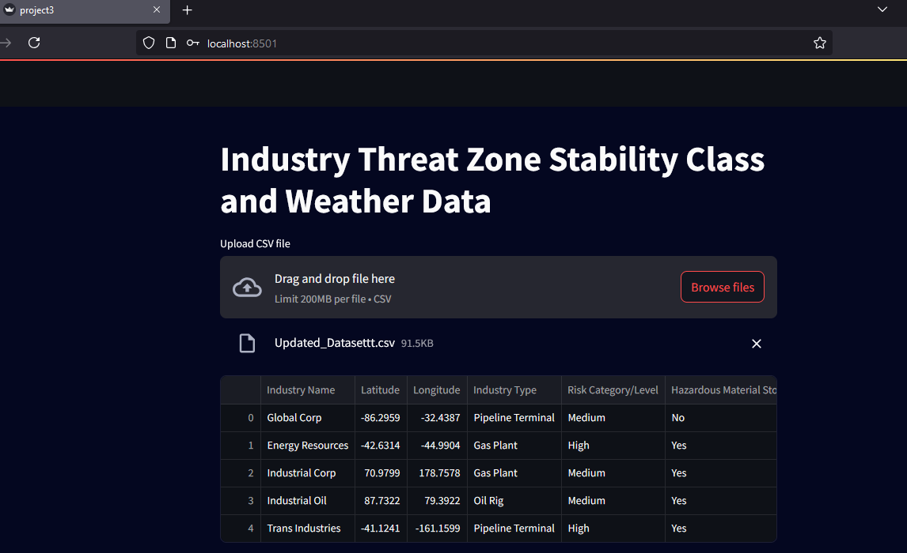

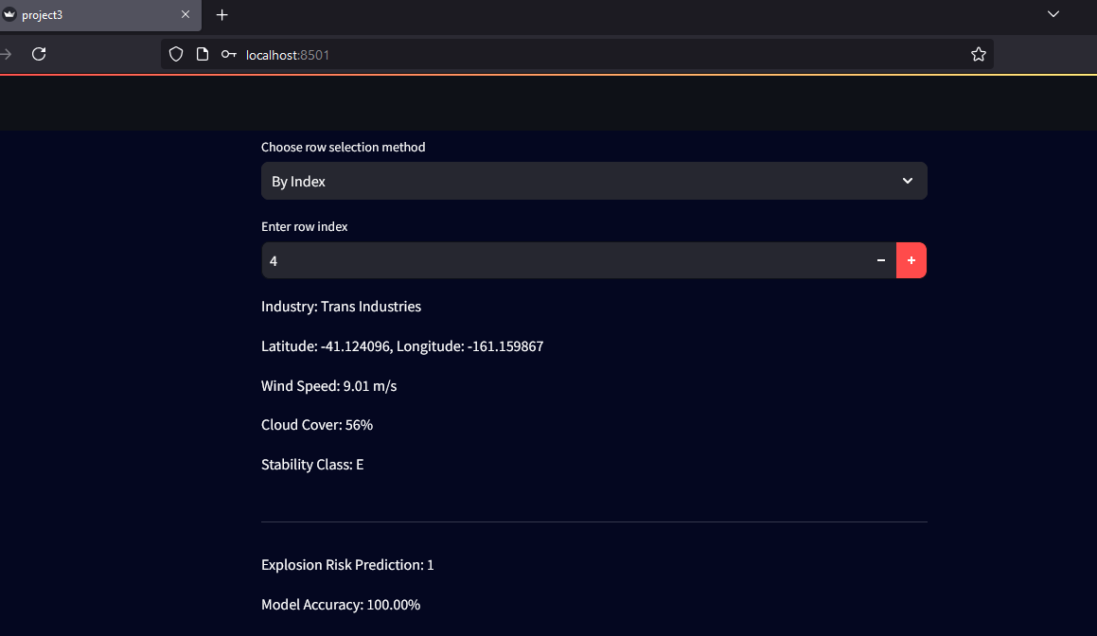

The result of our model achieved an accuracy of 92%, but the classification report shows that the model is only predicting the majority class ("0" - no explosion risk). Specifically: Precision, Recall, and F1-score for class "1" (explosion risk) are all 0.00, indicating that the model did not predict any instances of this class. The model is overfitting to class "0", likely due to an imbalance in the dataset (more instances of no explosion risk compared to high explosion risk).

Also, further improvements, such as fine-tuning and data augmentation, could increase the model's robustness for real-world applications. Hence, this study demonstrates the potential of deep learning in medicinal plant identification while laying the groundwork for future advancements. Future improvements for the project could involve fine-tuning the model's settings and using more data augmentation to diversify the dataset. Adding different real-world examples could also make the model more reliable and adaptable.

**5. Conclusion**

This study on identifying explosive risks using machine learning algorithms and its classifiers can successfully classify different gas and oil species by analyzing the data. The model achieved high accuracy, making it useful in fields like threat zone analysis and risk of gas and oil. However, its performance can change based on factors like the climate, Wind Speed, Cloud Cover, Solar Zenith Angle, Daytime Insolation (Q), Stability Class, and the variety of gases in the dataset, with some classes being hard to tell apart due to similar gases and oils. Future work should focus on adding more refinery samples to the dataset and using advanced methods to strengthen the model. Including details about gas characteristics and risks could also improve accuracy and expand its use, emphasizing the important role of machine learning in the gas classification and setting the stage for future research in automated classification systems.

**6. Declarations**

## 

## **6.1 Study Limitations**

The study faced limitations such as collecting industrial explosive gas and oil refineries data, the varying quality of gas and environmental conditions of it, which may affect the model's classification accuracy.

**6.2 Funding Source**

None.

**6.3 Acknowledgements**

I would like to express my sincere thanks to my Guide and Head of the department of Anurag University for their constant encouragement and motivation in my research work.

## **6.4 Informed Consent**

Informed consent was obtained from all participants involved in this research, ensuring that we fully informed ourselves about the study's purpose, procedures, and the use of our data in the publication of this work.

**7. References**

[1] [Witten, I. H.; Frank, E.; Hall, M. A.; Pal, C. J. Data Mining: Practical Machine Learning Tools and Techniques; Morgan Kaufmann: Amsterdam, 2017.](https://www.researchgate.net/publication/251275816_Witten_IH_Frank_E_Data_Mining_Practical_Machine_Learning_Tools_and_Techniques)

[2] [Scornet, E. Random Forests and Kernel Methods. IEEE Trans. Inf. Theory 2016, 62 (3), 1485−1500.](https://ieeexplore.ieee.org/document/7373647/)

[3] [Jiao, Z.; Yuan, S.; Zhang, Z.; Wang, Q. Machine Learning Prediction of Hydrocarbon Mixture Lower Flammability Limits Using Quantitative Structure-Property Relationship Models. Process Saf. Prog. 2020, 39 (2), e12103.](https://aiche.onlinelibrary.wiley.com/doi/10.1002/prs.12103)

[4] [Jiao, Z.; Escobar-Hernandez, H. U.; Parker, T.; Wang, Q. Review of Recent Developments of Quantitative Structure-Property Relationship Models on Fire and Explosion-Related Properties. Process Saf. Environ. Prot. 2019, 129, 280−290.](https://www.sciencedirect.com/science/article/abs/pii/S0957582019308110?via%3Dihub)